Final Assessment-Alternative Assessment
Semester | 202520 | Division | CIS
Assessment title in Syllabus | Final_Project_Portfolio | Program | Bachelor of Information Technology/ Bachelor of Information Systems
Course Code | CDS 2413
Course Title | INTRODUCTION TO DATA SCIENCE
Course Instructor |  | CRN
Assessment | Project Deliverable 2 – Machine Learning Model Report | Submission Date | Week 13
Student Declaration:
Academic Integrity Statement
In accordance with the HCT Academic Integrity Policy
• Students are required to refrain from all forms of academic integrity breaches as defined and explained by HCT.
• A student found guilty of having committed acts of academic integrity breach(es) will be subject to the relevant sanctions as outlined by HCT.
إفادة النزاهة الأكاديمية
وفقًا لسياسة كليات التقنية العليا للنزاهة الأكاديمية
• على الطلبة الإلتزام بلوائح وقواعد النزاهة الأكاديمية، كما هو مبيّن وموضح في السياسات والإجراءات الخاصة بكليات التقنية العليا.
• في حالة ارتكاب الطالب أي شكل من أشكال الإخلال بالنزاهة الأكاديمية، سيتعرض الى العقوبات الموضحة في السياسات ذات الصلة.
This assignment is entirely my/our own work except where I have duly acknowledged other sources in the text and listed those sources at the end of the assignment. I have not previously submitted this work to the HCT, or any other entity. I understand that I may be orally examined on my submission.

Student HCT ID(s): | H00502480 | H00502479 | H00566093 | H00
Student Name(s): | Muath Mohammed | Mohammed Faisal Alshehhi | Zayed Alblooshi
Student Signature | Muath | Mohamed | Zayed
Chatbot (e.g. ChatGPT) statement
This submission allows you to use AI generated tools, but the prompt used must be stated and the response must be in red font. Include References to ChatGPT.

Instructions

Remove instructions and hints from the template before submitting the final report to BBLearn.

CLO3: Machine Learning Model (25 Points)

Preprocessing(5 Points)

Data Collection (1 Point)
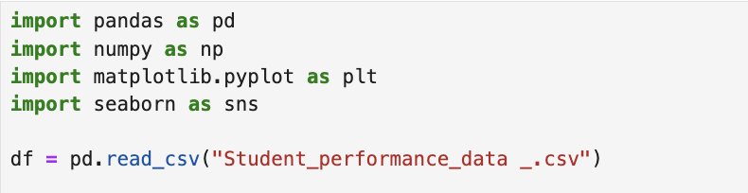

The dataset was loaded using the pandas library with the read_csv() function.
The file used in this project is Student_performance_data_.csv.
After loading the dataset, the main variables were selected for analysis and machine learning. These variables include GPA and other related features that help in predicting student performance.

Data Cleaning (1 Point)

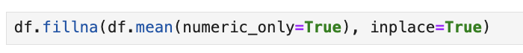

The dataset was checked and cleaned before building the model.
Missing values in the numerical columns were replaced using the column mean with fillna(). This step is important because it ensures that there are no empty values that may affect the model performance. After cleaning, the dataset became complete and ready for analysis.

Treating the Categorical Variables (1 Point)

In this project, the categorical variable is GPA_Category, which is a binary variable because it has only two values: High and Low.

The GPA values were converted into categories where values less than 2.5 are labeled as Low, and values equal to or greater than 2.5 are labeled as High.
To convert these categories into numerical values, LabelEncoder was used. The values High and Low were transformed into 0 and 1. This step is important because machine learning models cannot work with text data, so categorical values must be converted into numbers.
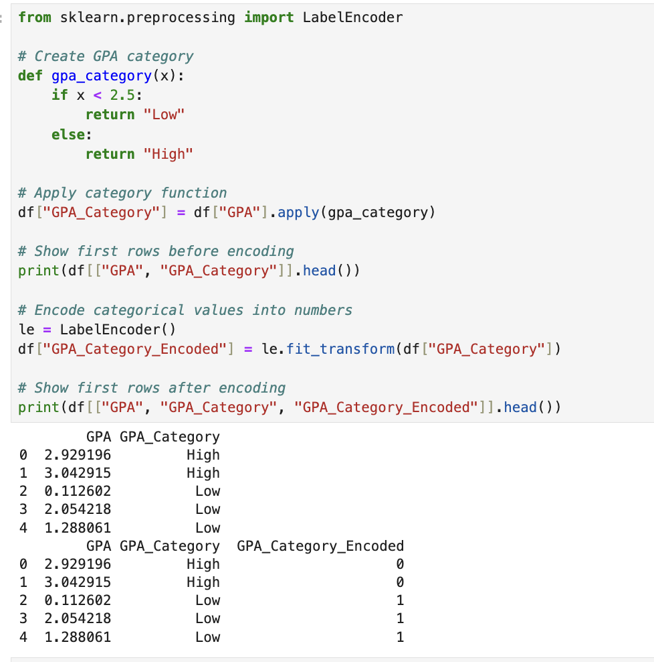

The GPA values were converted into categories to prepare the data for classification.
If the GPA is less than 2.5, it is labeled as Low, and if it is 2.5 or higher, it is labeled as High. This creates a binary categorical variable with two possible values.Then, LabelEncoder was used to convert these categories into numerical values (0 and 1). This step is important because machine learning models require numerical input to work correctly.

Splitting the Dataset (1 Point)
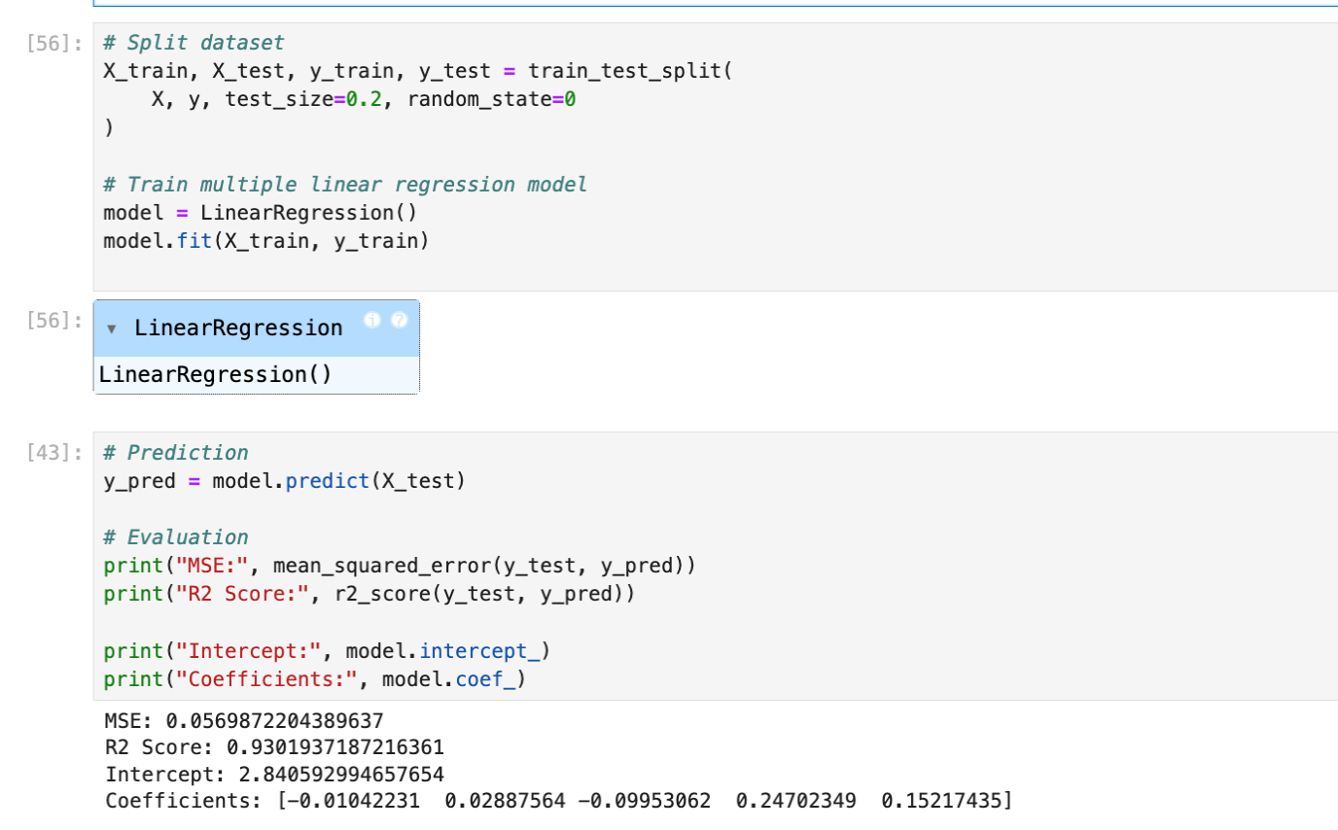

Splitting the dataset is important because it allows the model to be trained on one part of the data and tested on another part.

In this project, the dataset was split into 80% training data and 20% testing data using train_test_split(). This ratio is commonly used because it provides enough data for training while still keeping a good portion for testing.
It helps to evaluate how well the model performs on new unseen data and reduces the risk of overfitting.

Featuring the Dataset (1 Point)
Feature scaling was not applied in this project because the selected features are already in a similar range and do not have large differences.

In addition, linear regression models can still perform well without scaling when the data is simple. Keeping the original values helps make the model easier to understand and follows the method used in our class.

Regression Model (7 Points)

Building the Regression Model (6 points)

In this section we implement different regression models were implemented to predict the total score. These models include Multiple Linear Regression, Polynomial Regression, Ridge, Lasso, and Elastic Net.

Each model was trained using the dataset, and their performance was evaluated using R-squared (R²) and Mean Squared Error (MSE).

The best model was selected based on the highest R² value and lowest error. The predicted values were also compared with the actual values to analyze how well the model performs.

Steps to be followed:

1. Loading and Preprocessing the Data
- Load Dataset:
The dataset was loaded using the pandas library from a CSV file. The required columns such as StudyTimeWeekly, Absences, GPA, and GradeClass were selected for analysis. These features were used as independent variables for building the model.
- Handle Missing Values:
Missing values in the selected columns were replaced using the column mean to ensure that the dataset is complete and ready for modeling.
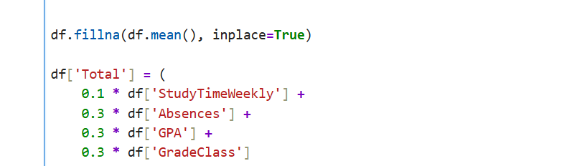

- Create Target Variable:
A new variable called Total was created as a weighted sum of the independent variables.
The formula used is:
Total = 0.1 × StudyTimeWeekly + 0.3 × Absences + 0.3 × GPA + 0.3 × GradeClass.
This variable is used as the target variable for the regression model.
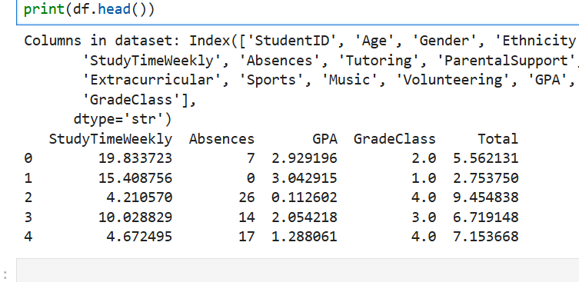

2. Detecting and Removing Outliers
- Outlier Detection:
Outliers were detected using the Interquartile Range (IQR) method.

For each independent variable (StudyTimeWeekly, Absences, GPA, and GradeClass), values outside the range [Q1 − 1.5 × IQR, Q3 + 1.5 × IQR] were considered as outliers.
These outliers were identified and removed to improve the performance and accuracy of the model.

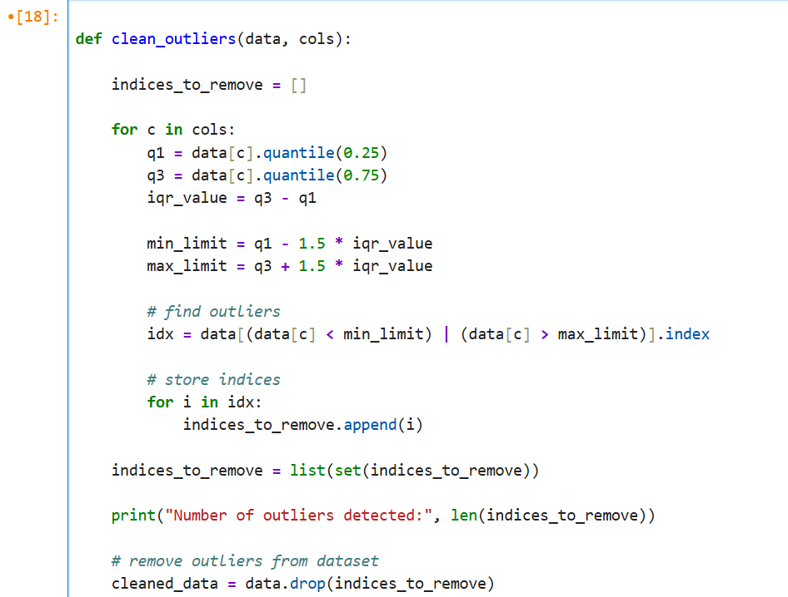
- Combine Outliers:
Outliers detected for all variables are consolidated into a single DataFrame and duplicates are removed to ensure each outlier row was counted only.

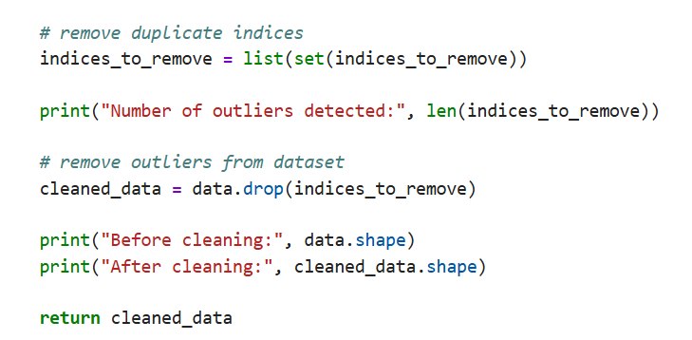
- Remove Outliers:
Rows corresponding to the detected outliers were removed from the dataset to improve model performance. This step helps increase accuracy and reduces the effect of extreme values on the model.
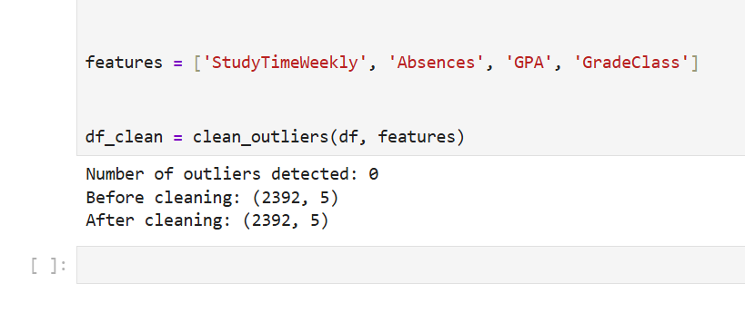

3. Splitting the Data
- Independent Variables (X):
The independent variables (X) were selected from the cleaned dataset (df_clean). These variables include StudyTimeWeekly, Absences, GPA, and GradeClass. They are used as input features for the regression model.
- Target Variable (y):
The target variable (y) is Total, which represents the overall performance of a student. It was calculated earlier as a weighted combination of the independent variables.
- Train-Test Split:
The dataset was split into training (80%) and testing (20%) sets using train_test_split(). This helps evaluate how well the model performs on unseen data and reduces the risk of overfitting.
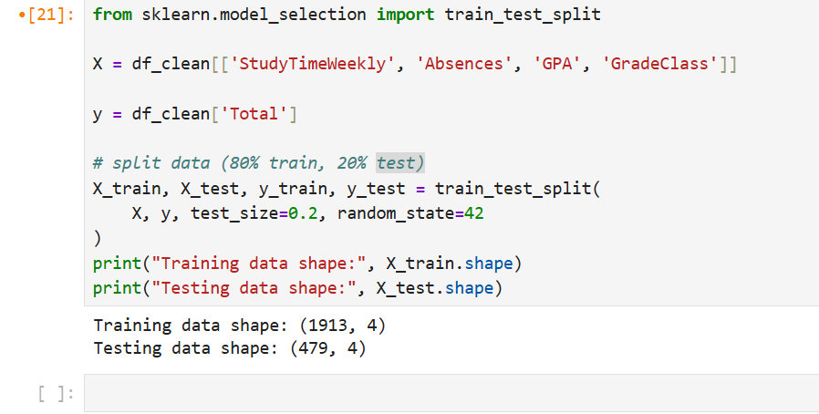

4. Applying Regression Models
- Regression Models:
Multiple regression models are applied to predict the target variable Total:
        - Linear Regression:
Linear Regression is used to model the relationship between the independent variables and the target variable. It fits a straight line to the data and predicts the output based on the input features. This model is simple and works well when there is a linear relationship between variables.
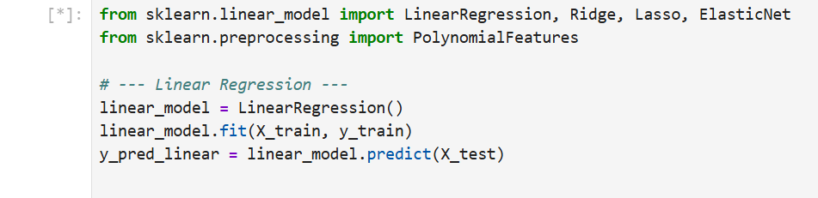

        - Polynomial Regression (Degree 2):
Polynomial Regression is used to model non-linear relationships by adding polynomial terms to the features. It can capture more complex patterns in the data compared to linear regression.
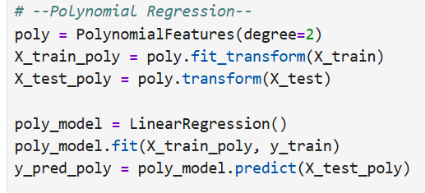
    - Ridge Regression:
Ridge Regression is a regularized version of linear regression that helps reduce overfitting. It adds a penalty term to the model to keep the coefficients small and improve generalization.
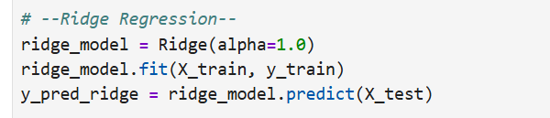
    - Lasso Regression:
Lasso Regression is similar to Ridge but uses a different penalty method. It can reduce some coefficients to zero, which helps in feature selection and simplifies the model.
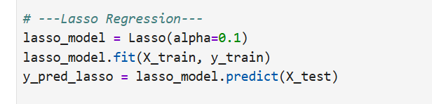
    - Elastic Net Regression:
Elastic Net combines both Ridge and Lasso regression techniques. It balances between reducing overfitting and selecting important features, making it useful for complex datasets.
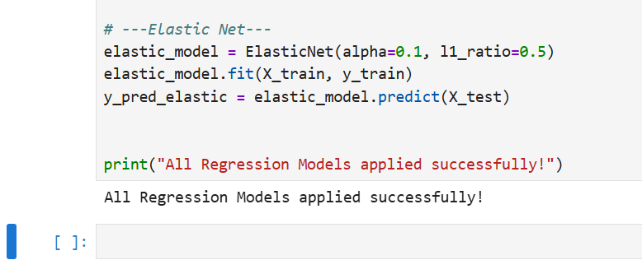
- Polynomial Features:
For polynomial regression, the features are transformed to include polynomial terms using PolynomialFeatures. Allows model to learn complex relationship
Regression Code :
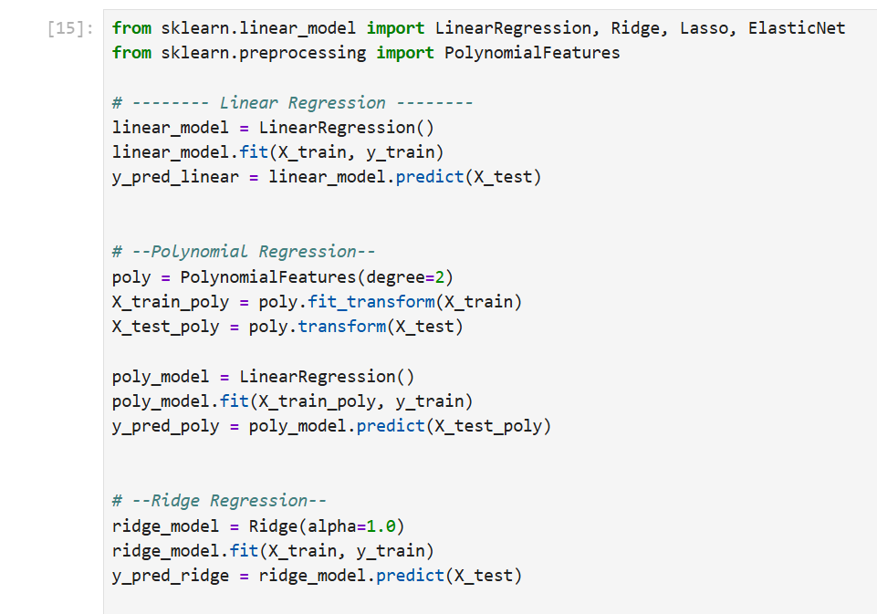
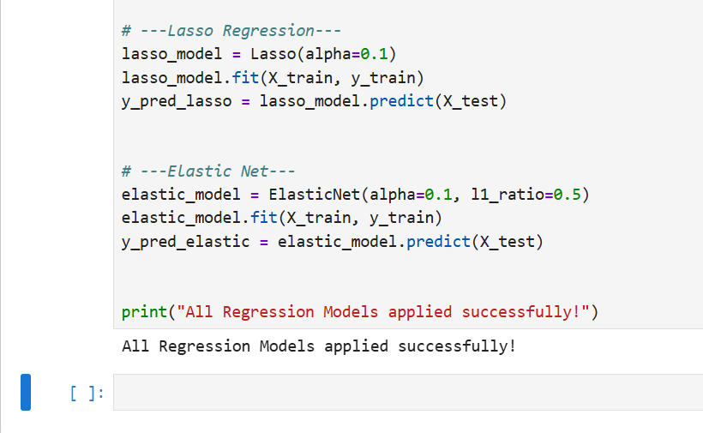

5. Evaluating Models
- Predictions:
Each regression model was applied to the test dataset to predict the target variable (Total). The predicted values were then compared with the actual values to evaluate how well each model performs.
- Evaluation Metrics:
To evaluate the performance of each model, two main metrics were used: Mean Squared Error (MSE) and R-squared (R²). These metrics help measure how accurate the model predictions are and how well the model fits the data.

  - Mean Squared Error (MSE):
Mean Squared Error (MSE) measures the average squared difference between the predicted values and the actual values. A smaller MSE value indicates better prediction accuracy.
  - R-squared (R²):
R-squared (R²) indicates how well the model explains the variation in the target variable. A value closer to 1 means that the model fits the data well and gives more accurate predictions.
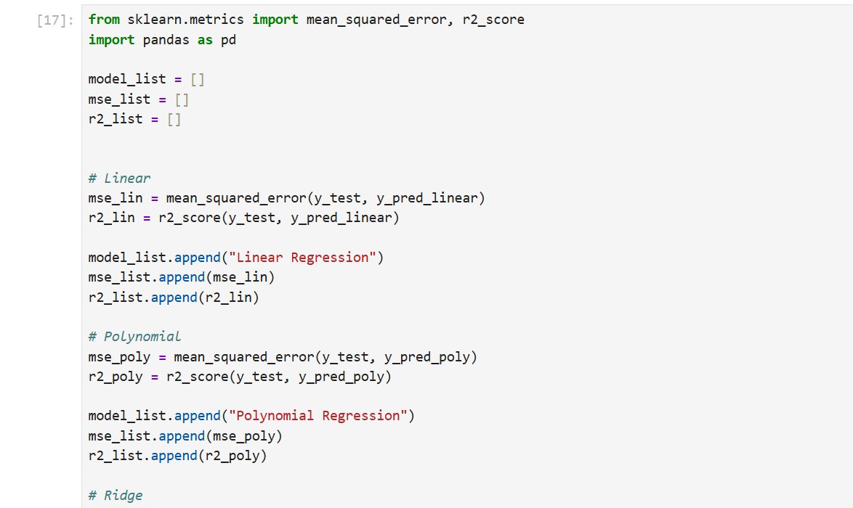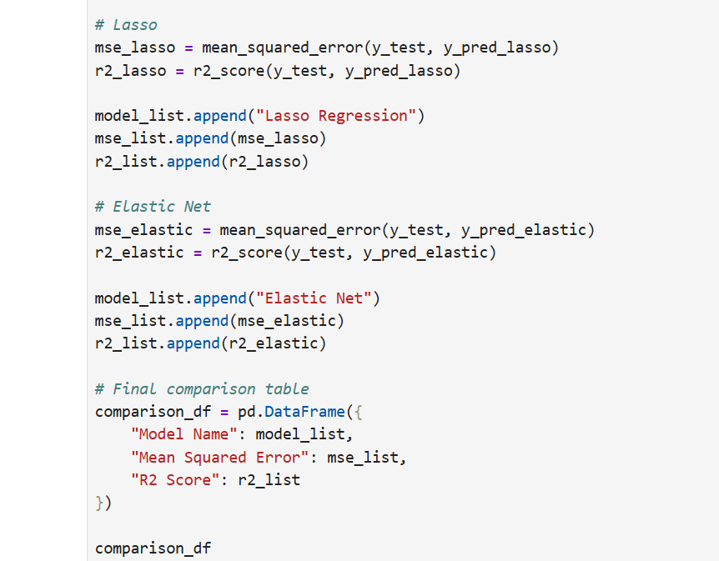

Comparison Table Output:
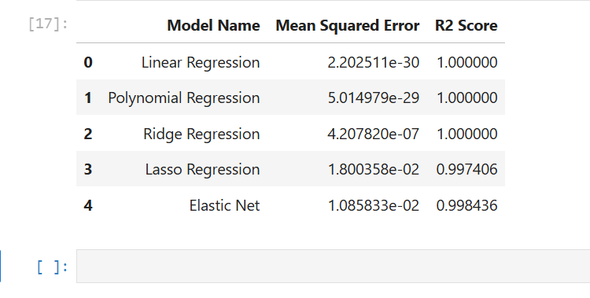

6. Selecting the Best Model
- Comparison Table:
A comparison table was created to evaluate the performance of all regression models. The table includes Mean Squared Error (MSE) and R-squared (R²) values for each model. This helps in comparing the models and understanding which one performs better.


- Best-Fit Model:
The best-fit model is selected based on the evaluation metrics. The model with the highest R² value and lowest MSE is considered the best because it provides more accurate predictions and better fits the data.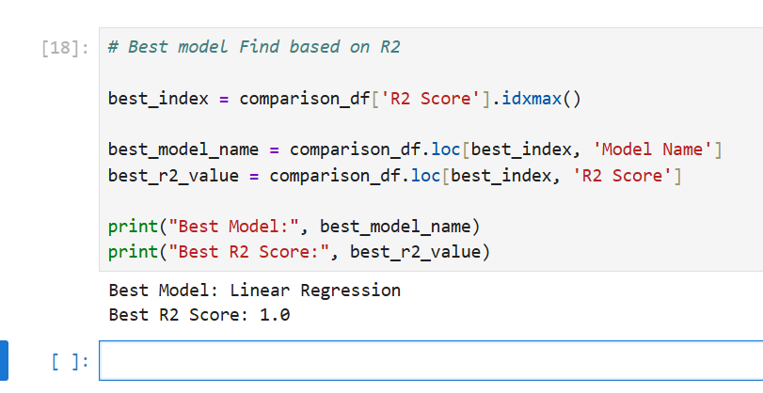
Based on the results, the best model is Linear Regression with an R² score of 1.0.This means that the model can perfectly explain the variation in the target variable and gives highly accurate predictions. Compared to the other models, Linear Regression achieved the best performance according to the evaluation metrics.

7. Printing the Regression Equation

- For Polynomial Regression:
Coefficients and intercept are used to construct the regression equation, including polynomial terms. Polynomial features were included to represent higher order relationship between variables.
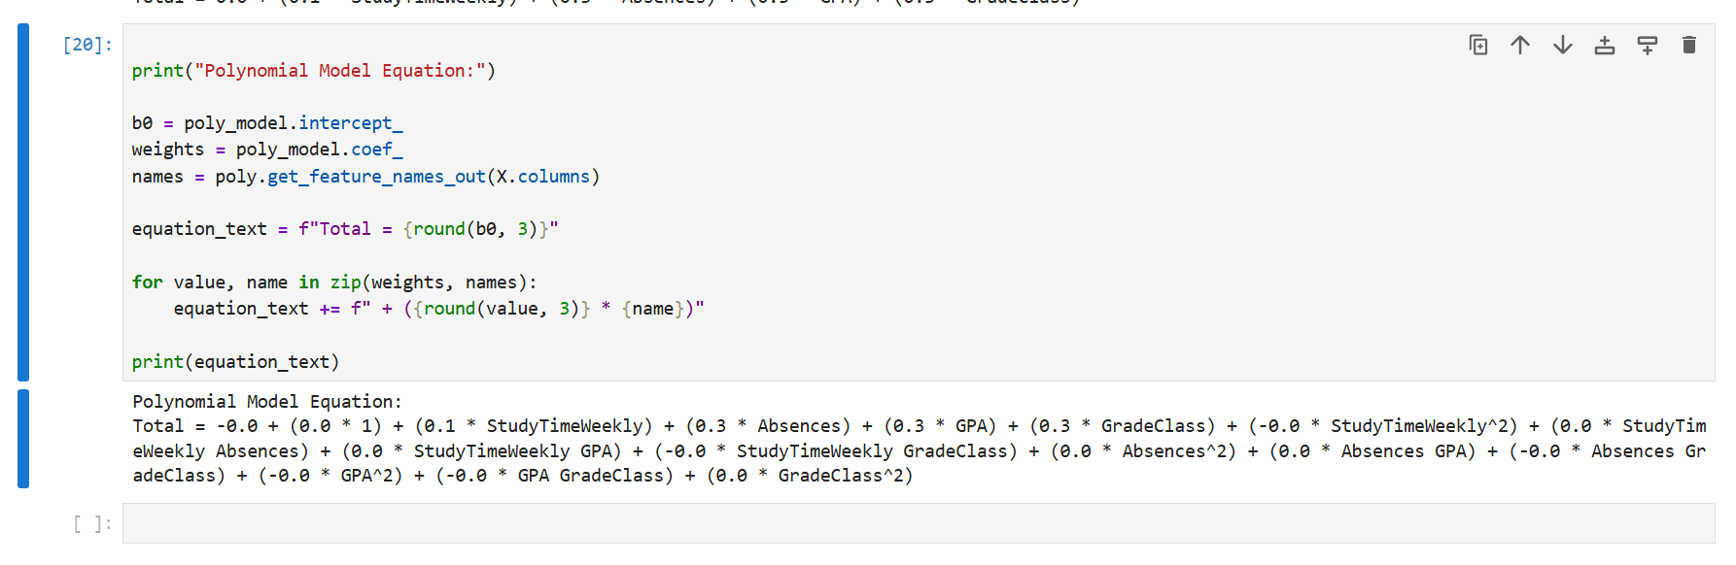

- For Other Models:
For other Regression Models Coefficients of the linear terms and the intercept are printed. These values represent the contribution of independent variable for predicting the target variable.

- Linear regression :
The regression equatiionn for the linear model was obtained using the iintercept and coeffiicents
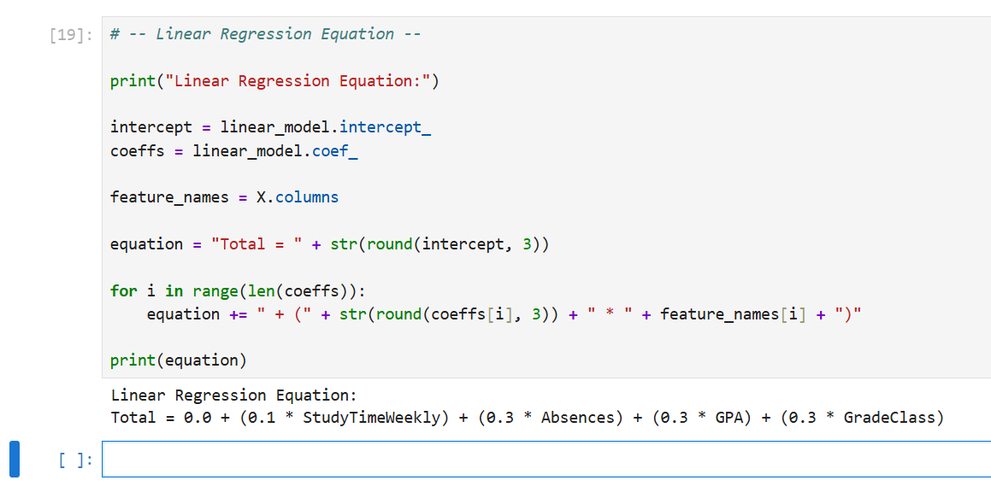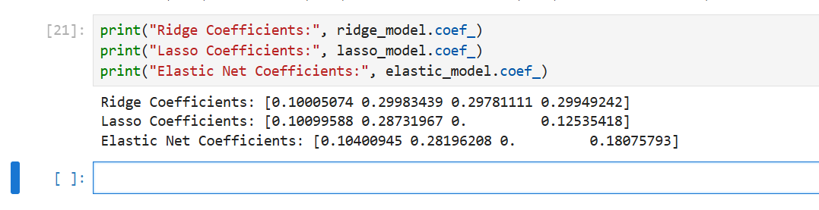

8. Visualization
- Observed vs. Predicted Values:
A Scatter plot was used to compare the actual values (y test) with then predicted ones genetatrated and conclude by the linear regression model . each point in the graph is representing a comparison between actual and predicted output values.
A straight diagonal line is included in the plot to indicate accurate idieal prediction. Which The point appears near the line when predicted value is closer ro the actual value
In this model, most of the points are very close to the diagonal line, which indicates that the model is performing accurately.
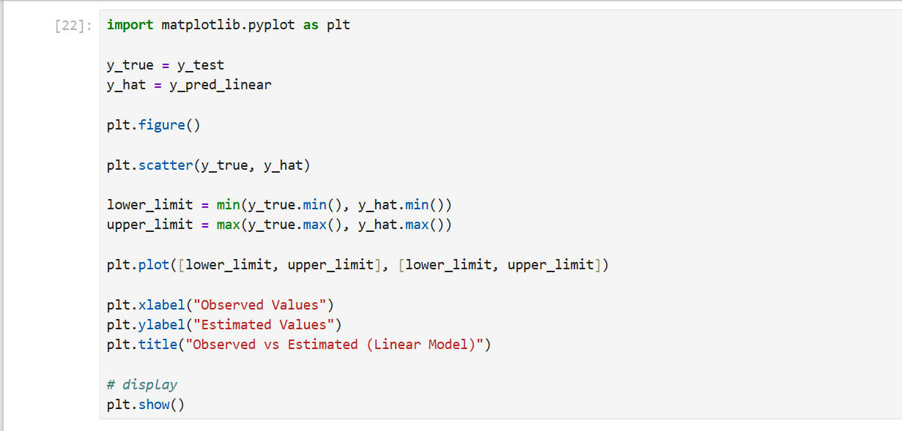

Graph:
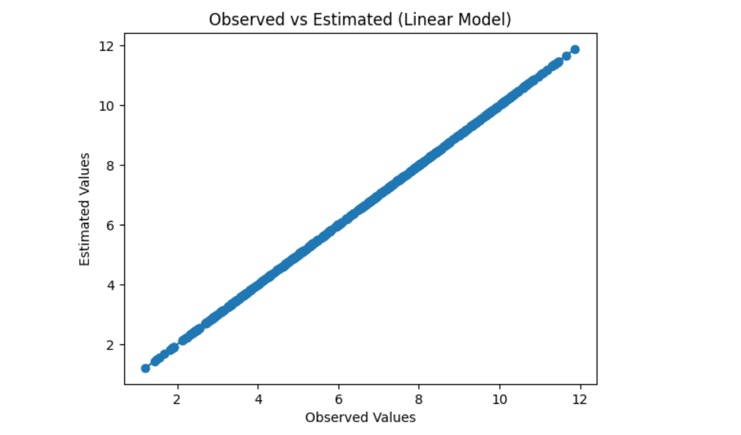

Deriving the Regression Equation the Dataset (1 point)

The regression equation was derived using the intercept and coefficients of the best-performing model, which is Linear Regression.

This equation is used to calculate the predicted values of the target variable based on the independent variables.

1. Regression Equation

The regression equation is:

Total = 0.0 + (0.1 × StudyTimeWeekly) + (0.3 × Absences) + (0.3 × GPA) + (0.3 × GradeClass)

2. Selection of Random Records:

StudyTime Weekly | Absences | GPA | GradeClass
2.8225 | 4 | 2.5671 | 2
9.0309 | 16 | 1.8138 | 4
11.2271 | 24 | 1.2912 | 4
19.2557 | 18 | 1.5348 | 4
18.4500 | 5 | 2.4897 | 3

Five random records were selected from the dataset to calculate the predicted values manually.

3. Substitution of Values
The values from the selected records were substituted into the regression equation to calculate the predicted Total values manually.

Row 1

Total = 0.1(2.8225)+ 0.3(4) + 0.3( 2.5761) + 0.3(2)

= 0.2822 + 1.2 + 0.7728 + 0.6
= 2.855

Row 2

Total = 0.1(9.0309) + 0.3 (16) + 0.3 (1.8138) +0.3(4)

= 0.9031 + 4.8 + 0.5441+ 1.2
=7.447

Row 3

Total = 0.1( 11.2271) + 0.3(1.2912) +0.3(4)
= 1.1227 + 7.2 + 0.3873 + 1.2
= 9.910

Row 4

Total = 0.1(19.2557)+ 0.3(18) +0.3(1.5348)+ 0.3(4)
=1.9256 +5.4 +0.4604+ 1.2
=8.986

Row 5

Total = 0.1 (18.4500 )+ 0.3 (5) + 0.3 ( 2.4897) + 0.3(3)
=1.845 + 1.5 + 0.7469 + 0.9
=4.992

4. Final Table

Actual Total | Predicted Total
2.855 | 2.855
7.447 | 7.447
9.910 | 9.910
8.986 | 8.986
4.992 | 4.992

Graph:

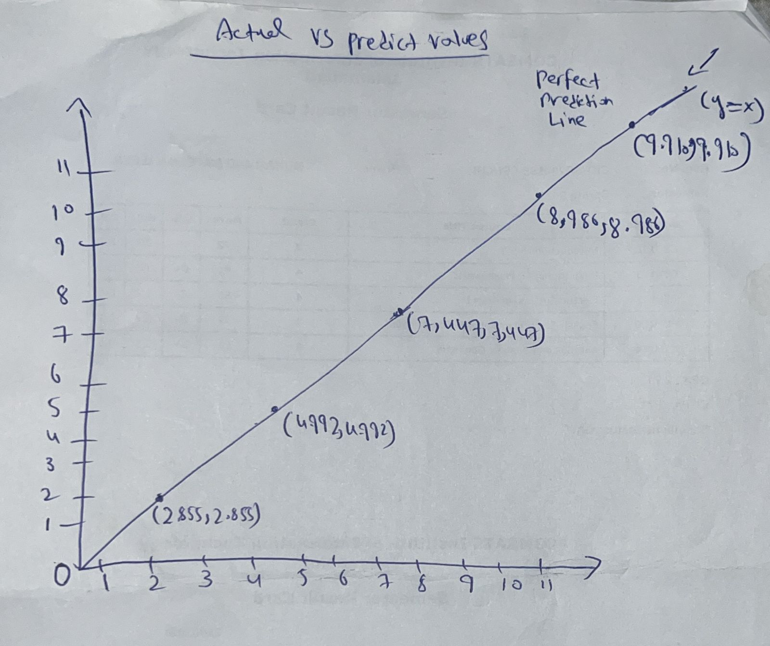

5. Final Explanation:

To calculate the predicted values, five records were selected from the dataset and substituted into the regression equation. The results show that the predicted values are very close to the actual values. Most of the points lie near the diagonal line, which indicates that the model provides accurate predictions.

Classification Model (8 Points)

Classifying the dataset based on the target variable (1 Point)

In this step, the target variable Total was converted into categorical values for classification.

The following categories were defined:
- Low (Total < 5)
- Medium (5 ≤ Total ≤ 7)
- High (Total > 7)

This helps transform numerical values into categories, which makes the data suitable for classification models.

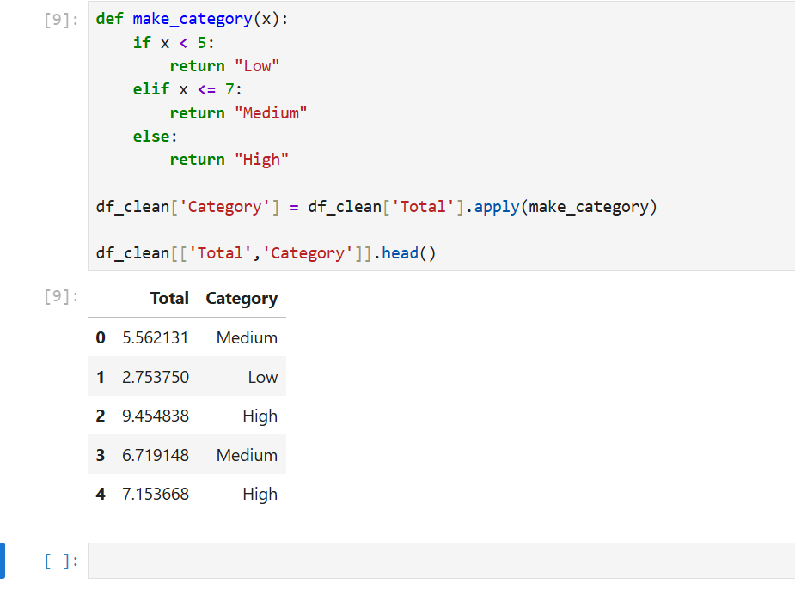

Bulding classification models (6 Points)
Different classification models were implemented to classify the data, including Logistic Regression, K-Nearest Neighbors (KNN), Support Vector Machine (SVM), Decision Tree, and Random Forest.

Each model was evaluated using accuracy, precision, recall, and F1-score.

These metrics help measure how well the model performs in classification tasks.

The best model was selected based on the highest accuracy and overall performance.

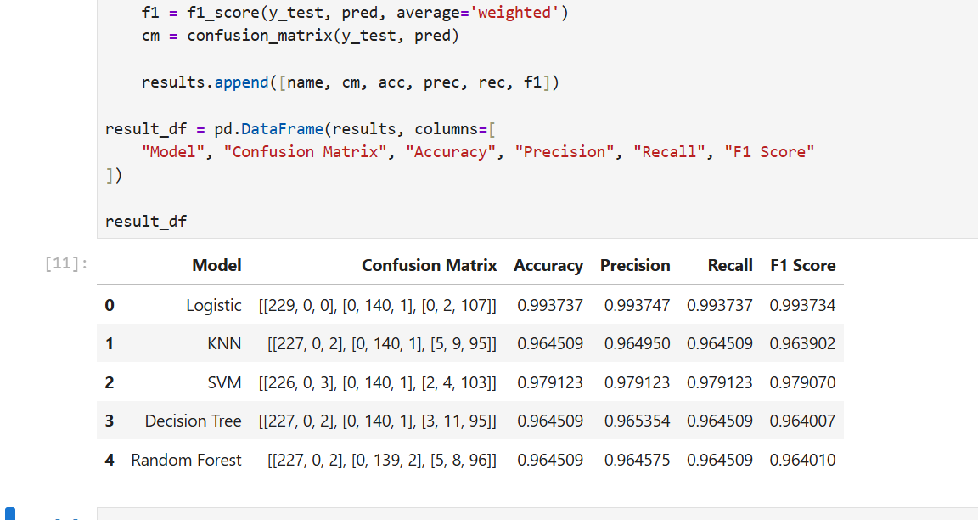

Based on the evaluation results, the best classification model is Logistic Regression.
This model achieved the highest accuracy compared to the other models, which indicates better performance in classifying the data. It also shows high precision, recall, and F1-score, which means the model is reliable and performs well across different evaluation metrics.

No of elements on the target variable (1 Point)

The number of elements in each category was calculated based on the classification results. This helps to understand the distribution of the data across different categories.

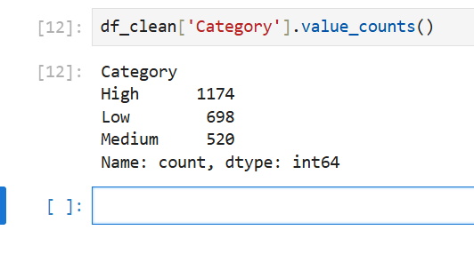

Cluster Analysis (5 Points)
Building the Cluster Analysis(3 Points)

K-Means clustering was applied to the dataset to group similar data points based on selected features.

The Elbow Method was used to determine the optimal number of clusters.

After identifying the best number of clusters, the data was visualized to understand how the data points are grouped.

Elbow Graph:

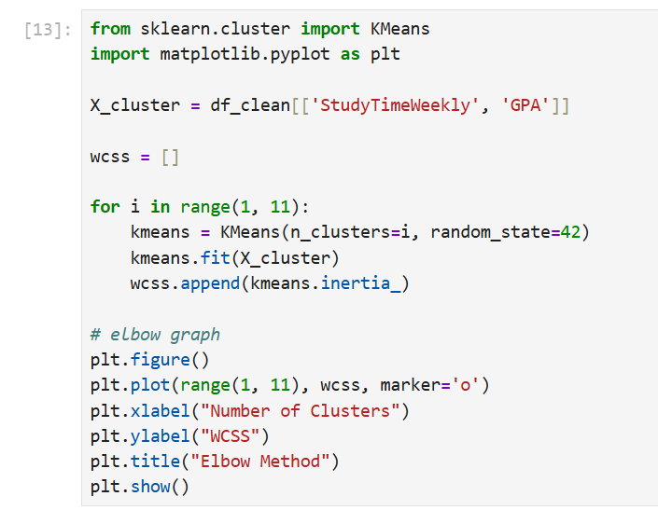
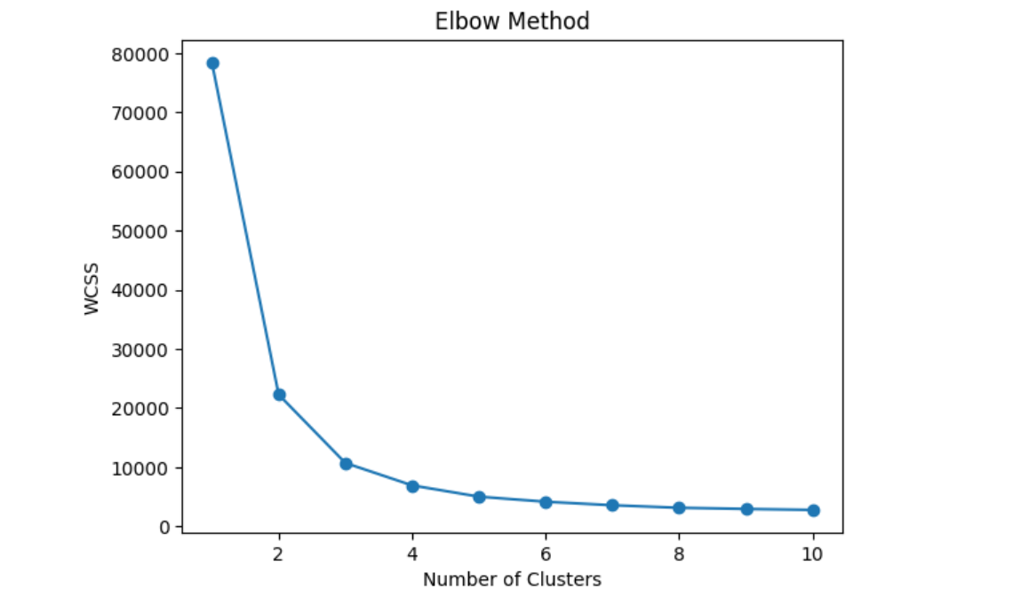

The Elbow Method graph shows how the WCSS value decreases as the number of clusters increases.

The optimal number of clusters is chosen at the point where the decrease becomes slower, which forms an “elbow” shape in the graph.

Cluster Graph:

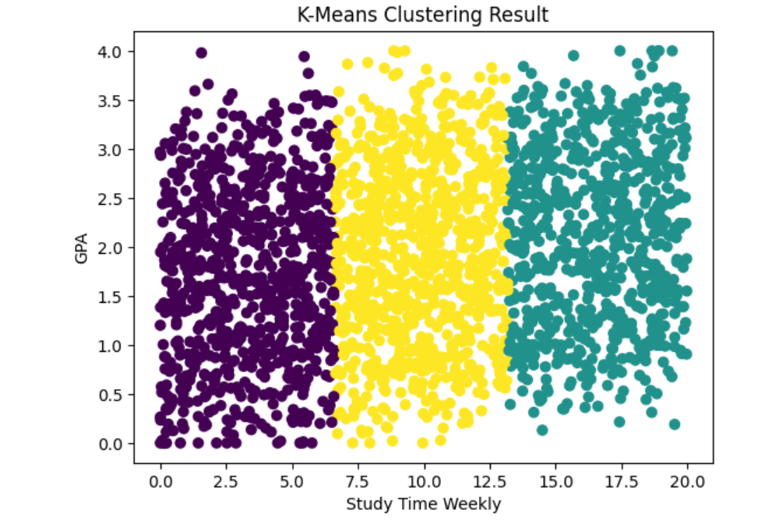

The cluster graph shows how the data points are grouped into different clusters based on StudyTimeWeekly and GPA. Each color represents a different cluster.

Strategy Formulation(2 Points)

The clustering results divided the dataset into three groups:

Cluster 0:
Students with low study time and low GPA. These students need more support and attention to improve their performance.

Cluster 1:
Students with average study time and average GPA. These students are performing moderately and need guidance to improve further.

Cluster 2:
Students with high study time and high GPA. These students are performing well and should maintain their performance.

